
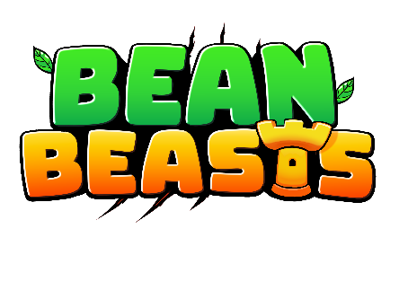
Bean Beasts Launches on Nintendo Switch!
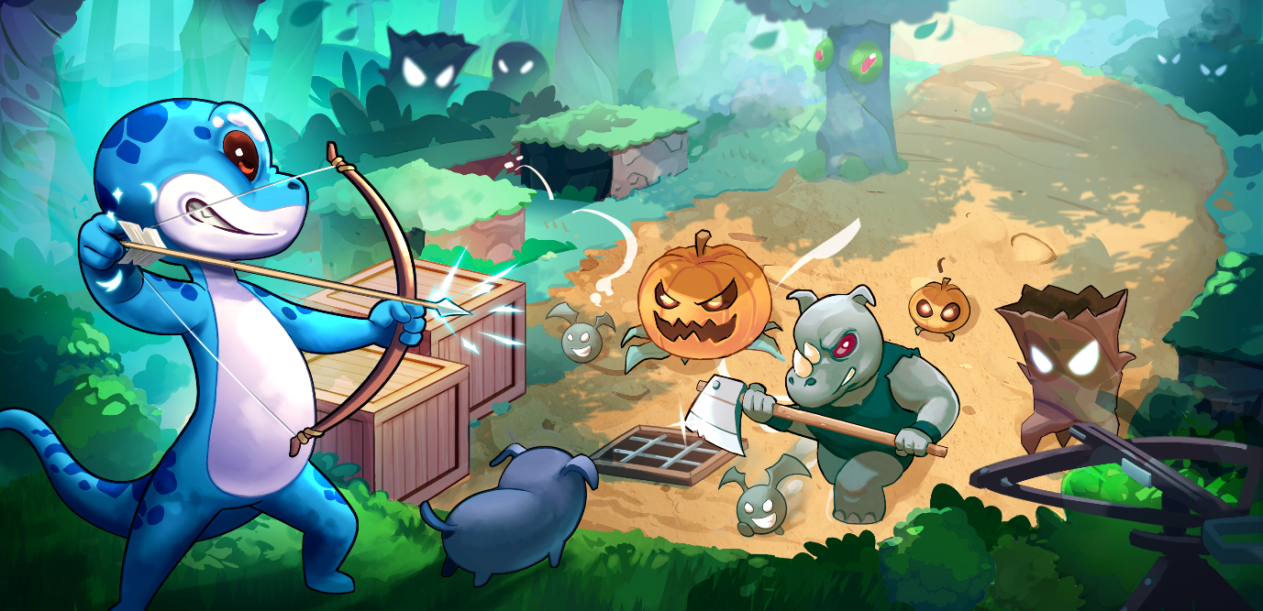
Bean Beasts is coming to Nintendo Switch on March 12, 2026, bringing a charming, chaotic creature-filled experience to players worldwide. Originally released on Steam August 2025.

Key Details
- Platform: Nintendo Switch
- Store Page Live: February 5, 2026
- Release Date: March 12, 2026
- Price: $9.99 USD (regional pricing may vary)
- Markets: Americas, Europe & Australia, Japan & Korea
- Languages: English, Spanish, German, Portuguese,
French, Japanese, Chinese (Simplified)

Embargo: Please do not publish coverage until February 5, 2026

Trailer, Screenshots, Artwork & GIFs: Link to Press Kit!

Developer Contact: Josh Bailey
josh@anxiousnoobgames.com
Developed by solo developer Anxious Noob, Bean Beasts is a polished creature-collecting tower defense game that blends strategic depth with expressive, evolving companions and large-scale boss encounters, climaxing with titanic battles against dinosaurs!

Originally released on Steam in August 2025, Bean Beasts launched with over 20,000 wishlists and secured a spot in Steam’s New & Trending category. The game had been featured on OTK’s “Pixel Pitch”, hosted by Asmongold, where it received funding to localize and bring the experience to Nintendo Switch. The upcoming Switch release fulfils that original vision, delivering a refined version of the game to a global console audience.
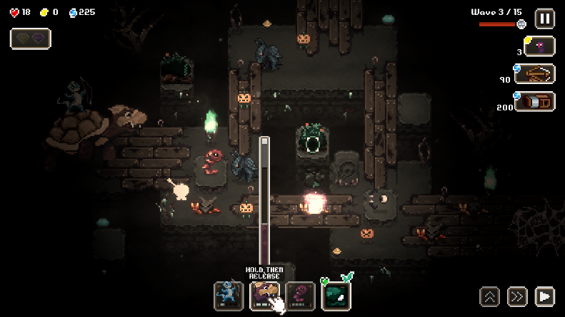
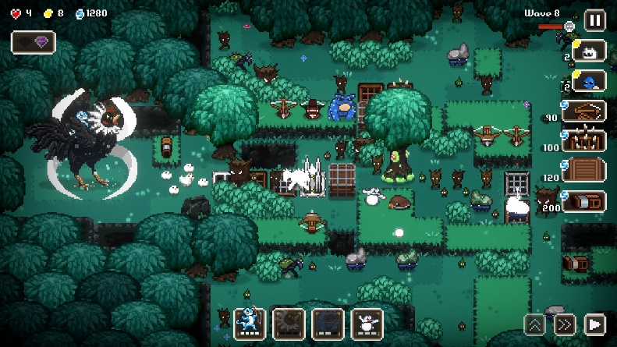

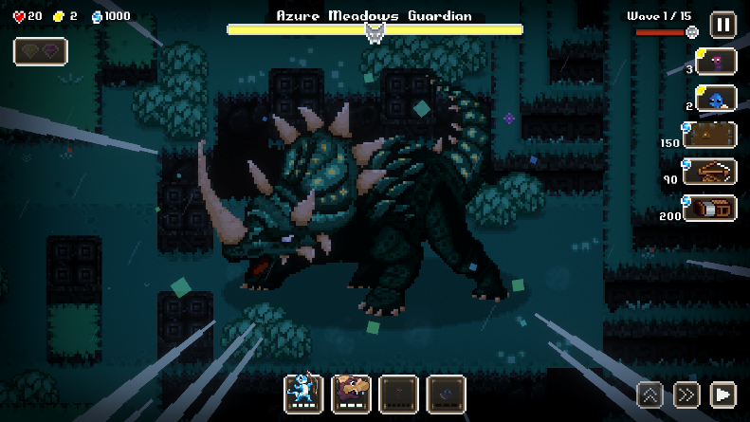
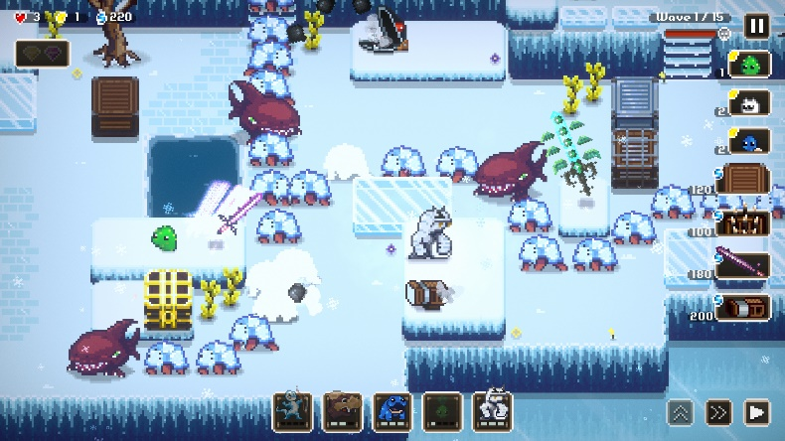

Additional Links:
Steam Store Page: https://store.steampowered.com/app/2631450/Bean_Beasts/
OTK’s Pixel Pitch Show: https://www.youtube.com/watch?v=qpWUBU6qO7E

Socials
YouTube | Blue Sky | X | Instagram


